Session : Introduction to linux

1. 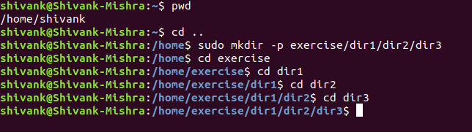

2.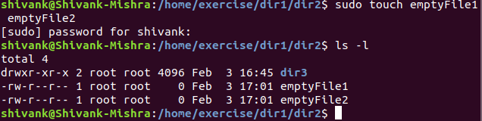

3.
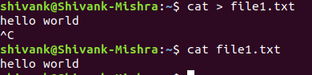

4.
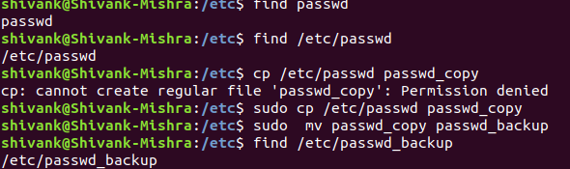
5. (i) less /etc/passwd_backup
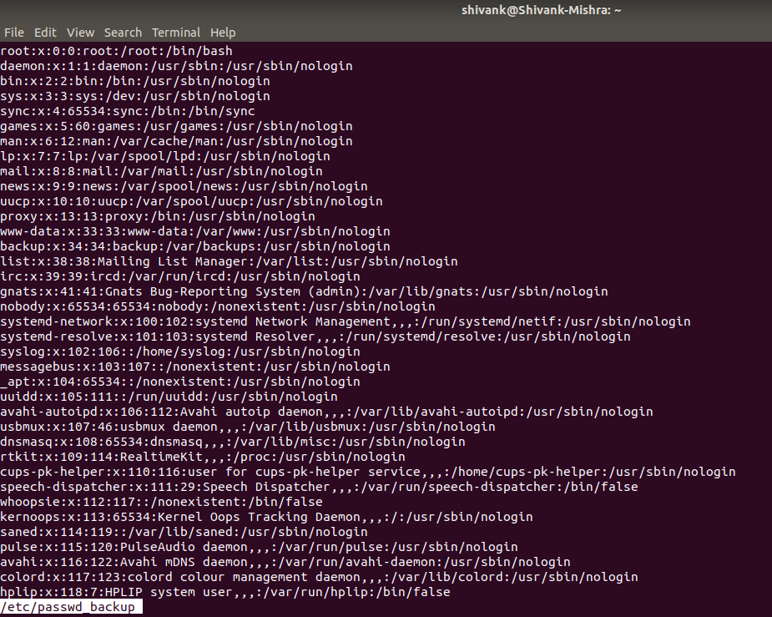

(ii) more /etc/passwd_backup
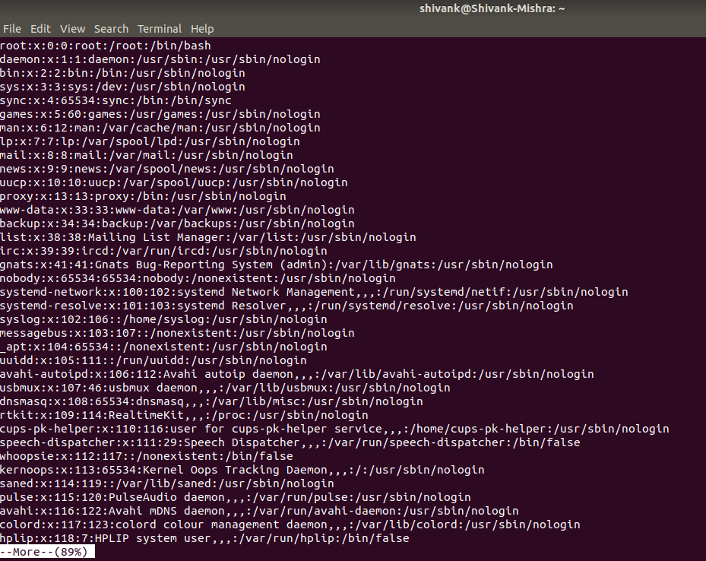

(iii) cat /etc/passwd_backup
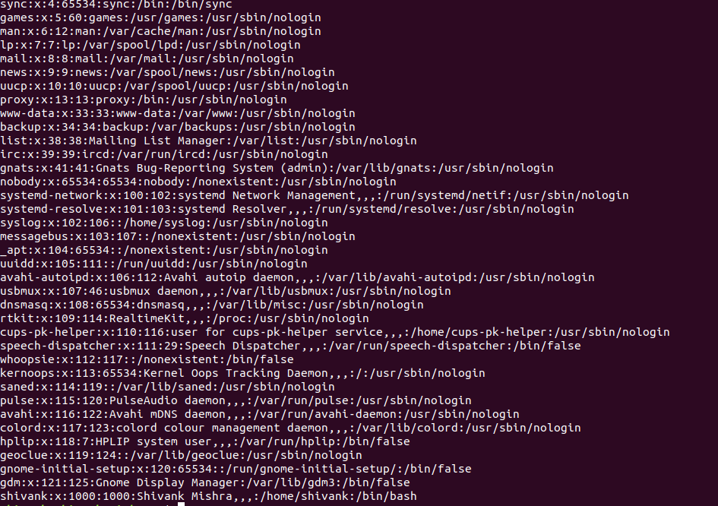

(iv) strings /etc/passwd_backup

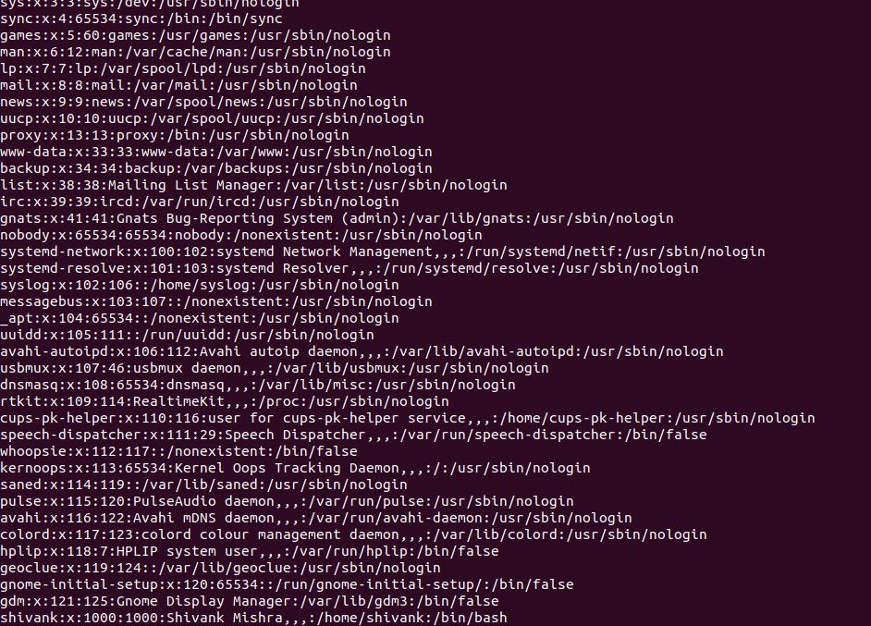

6.

7.
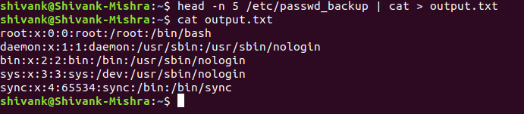

8.

useradd test

9.

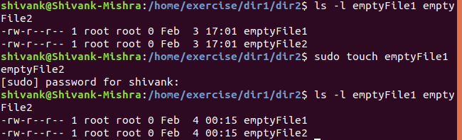

10.

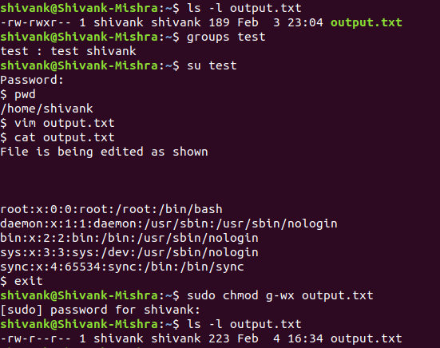

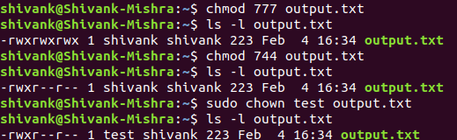

11.



12.

gedit ~/.bashrc

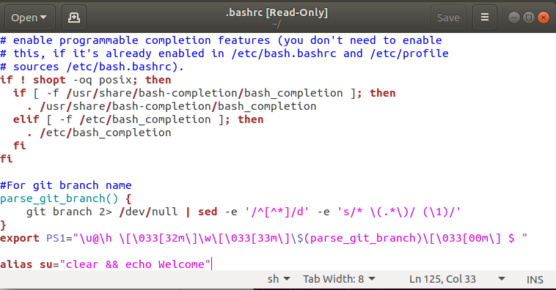

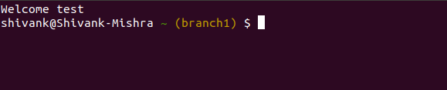

13.
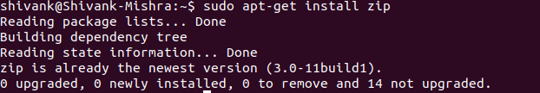

14.

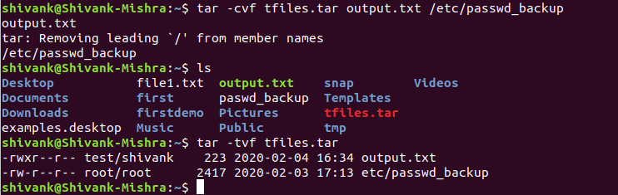

15.

16.
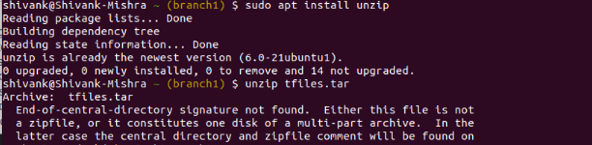

17.
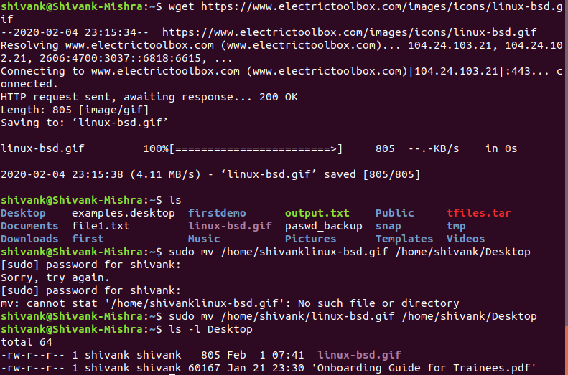

18.

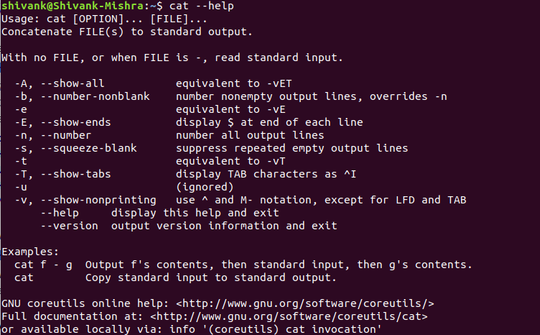

19.

20.

